Title: | Door Control Unit  SW Component SerialManager Version 1.2

History
Issue status  (Index) | Maturity/Date  (draft/invalid/valid)  (dd-mmm-yyyy) | Author  Department | Check/Release  Department | Description
1.0 | Draft  04-0ct-20 | Miguel Garcia | Miguel Garcia | Creation of the document.
1.1 | Valid  28-Jan-2021 | Shiomar Salazar |  | First release of the SDD Document for SerialManager.
1.2 | Valid  25-03-2021 | Shiomar Salazar |  | Update after Implementation

Table of Contents
1 Purpose 3
2 Definitions and abbreviations 3
2.1 Definitions 3
2.2 Abbreviations 3
2.3 References 3
3 Realization, constraints and targets 3
4 SW Conceptual design 4
4.1 Use Case Diagram 4
4.2 Block Definition Diagram 4
5 SW Component internal breakdown 5
5.1 Functional Decomposition 5
5.2 Function Description and Dynamic Behavior 6
5.2.1 Function void SerialManager_Init (void) 6
5.2.2 Function void DBG_Error (char* module , char* text) 6
5.2.3 Function void DBG_Print (char* module, char* text) 7

Purpose
This document is intended to provide a complete and necessary guide on the Software Detail Design of the Serial Manager Component for the Door Control Module project; this document will provide different diagrams and specifications needed to implement by the SerialManager SWC, in order to fulfil all the customer requirements. In addition, this document will capture and summarize all the significant architectural decision, which have been made for this SWC.

Definitions and abbreviations

Definitions

Abbreviations
DCM | Door Control Module
SWC | Software Component
DD | Driver Door
PD | Passenger Door
RRD | Rear Right Driver
RLD | Rear Left Driver
SW | Software
HAL | Hardware Abstraction Layer
DBG | Debug

References
N° | Document name | Reference
1 | “Traceability Matrix Template.xls” Version 2 | \V_Project_UDG_Eq4\documentation\V-Cycle Process\1.0 Requirements
2 | “Proyecto_DoorControlModule.docx” | \V_Project_UDG_Eq4\documentation
3 | SWA_DoorControlModule.pdf | \V_Project_UDG_Eq4\documentation\V-Cycle Process\2.0 Architecture\

Realization, constraints and targets

SerialManager SWC will no address any of the customer requirements, this SWC was decide to be included in the Architecture of the full project (please refer to the Architectural Design) to ensure a debug interface during the development process.
With this SWC the developer (and sometimes the tester) will have extra information on what is the DCM status in run-time, allowing easy and meaningful debug, reducing time and cost of fixing any SW bug.

SW Conceptual design

Use Case Diagram
The SerialManager SWC has only to actors that use it, DCM_App, been the main algorithmic function will be triggering all the necessary debug serial prints functions, and ErrorManager SWC, which will handle the errors thrown by the DCM_App and will log some error serial Logs.

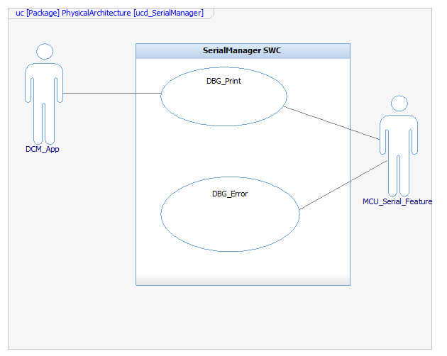

Block Definition Diagram

The SerialManager SWC will interact with the previously mention SW (DCM_App and ErrorManager), to do so the iSerialLog will be use, this interface contains the two methods need for each actor to post the necessary information on the Serial Bus.

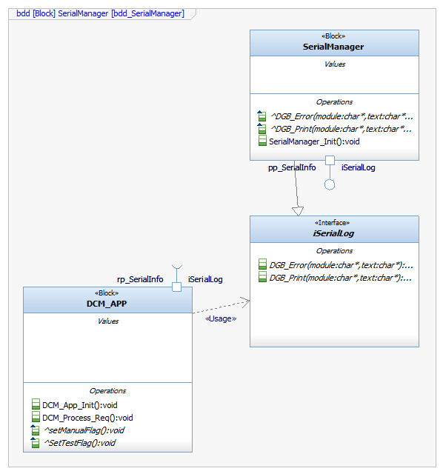

SW Component internal breakdown

Functional Decomposition
This SWC is composed of three main functions, an Initialization function and one function for both type of Serial log the DCM has available (Debug Print and Error Print).

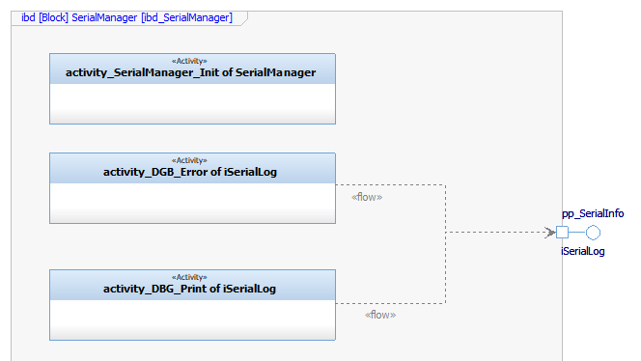

Function Description and Dynamic Behavior

Function void SerialManager_Init (void)

Description | This function perform all the necessary step (of the MCU Layer) to set up the Serial Bus connection.
Parameter 1  void | N/A
Return Value | N/A
Precondition | The OS call this function during the initialization process, hence no preconditions.
Post condition | N/A
Error Conditions | N/A
Requirements | This SWC does not fulfil any Customer Requirements.

Dynamic Behavior
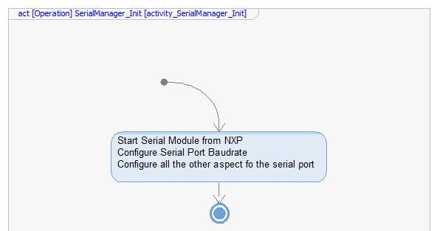

Function void DBG_Error (char* module , char* text)
Description | This function will cast the given inputs and send it over the Serial Bus with the Error Legend and a distinct font color.
Parameter 1  input | module: this char pointer will contain the module triggering the DBG for formatting.
Parameter 2  input | text: this char pointer will contain the error message to be displayed on the Serial Bus.
Return Value | N/A
Precondition | This function can only be called after the Initialization Function was executed.
Post condition | An Error log shall appear on the Serial Bus.
Error Conditions | Input been empty, which will make the function to do nothing.
Requirements | This SWC does not fulfil any Customer Requirements.

Dynamic Behavior
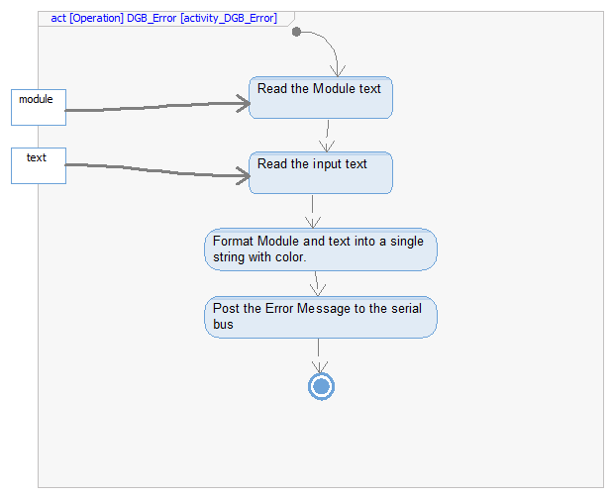

Function void DBG_Print (char* module, char* text)
Description | This function will cast the given input and send it over the Serial Bus with the Print Legend and a distinct font color. This function will be used to inform the developer (or anyone with serial access) of the current action taken by the DCM module, i.e., printing the current inputs of the algorithm, or the change on the variable, or any other information the Developer consider useful during development.
Parameter 1  input | module: this char pointer will contain the module triggering the DBG for formatting.
Parameter 2  input | text: this char pointer will contain the message to be displayed on the Serial Bus.
Return Value | N/A
Precondition | This function can only be called after the Initialization Function was executed.
Post condition | A print log shall appear on the Serial Bus.
Error Conditions | Input been empty, which will make the function to do nothing.
Requirements | This SWC does not fulfil any Customer Requirements.

Dynamic Behavior
